Below is the website page that you have to design using HTML+CSS, JS and Bootstrap.

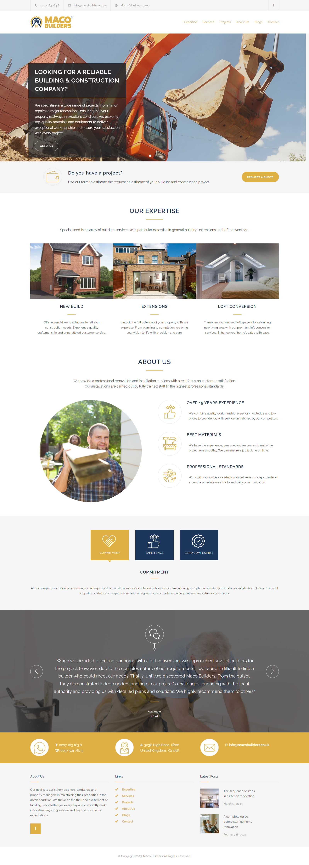



Below each section is discussed as under.

  
  
Header should be like above image, firstly on the left side there should be a logo and on the right side there should be a menu list.  
  
  
There should be a tooltip and a hover effect on the menu like mentioned in the above image.

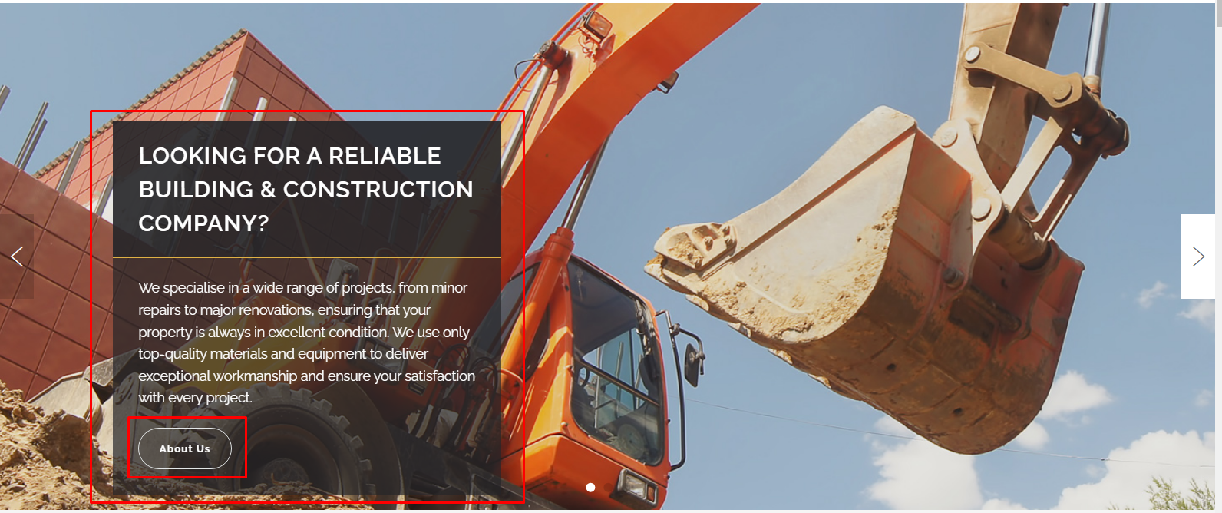

There should be slider like this mentioned in the above image first the background image will appear with fade effect and then this highlighted box will fade-in and show after 1 second. The button on the box also has hover effect like this  
mentioned in the below image.

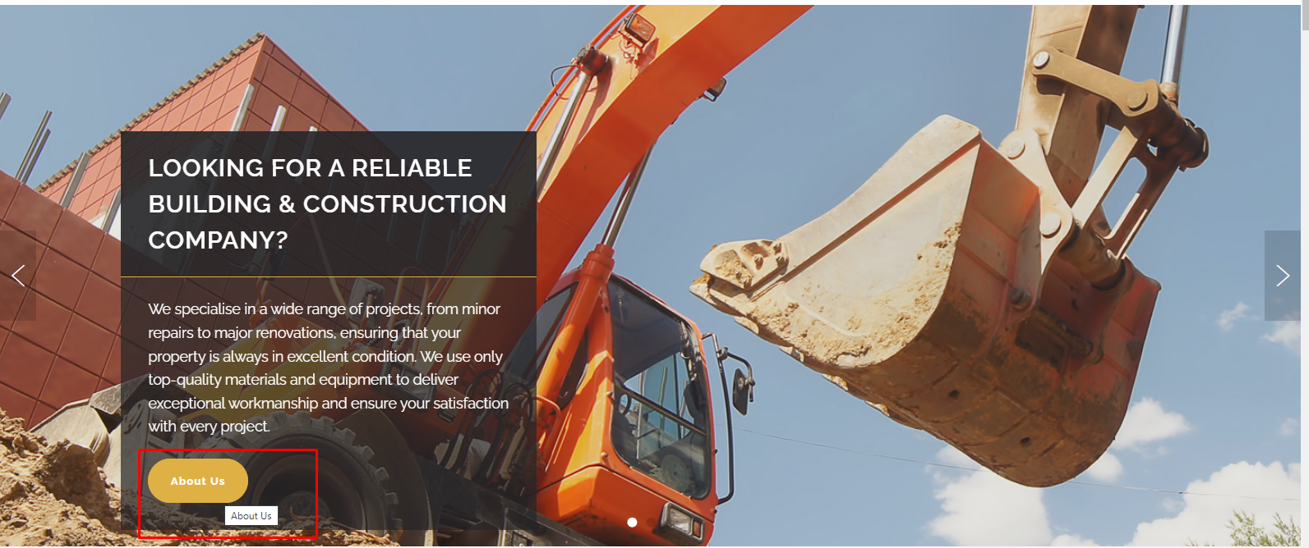

After slider is this section.  


Then add a section like mentioned in the below image.  


Then add this ‘About Us’ section.  
  


And then a section like this.  


There should be a hover effect like this.  
  
  
 And then add the testimonial slider like this.  


The background image is fixed only the text changes with slide when we click any of the slider buttons

And there should be hover effect on the buttons like this.  
  
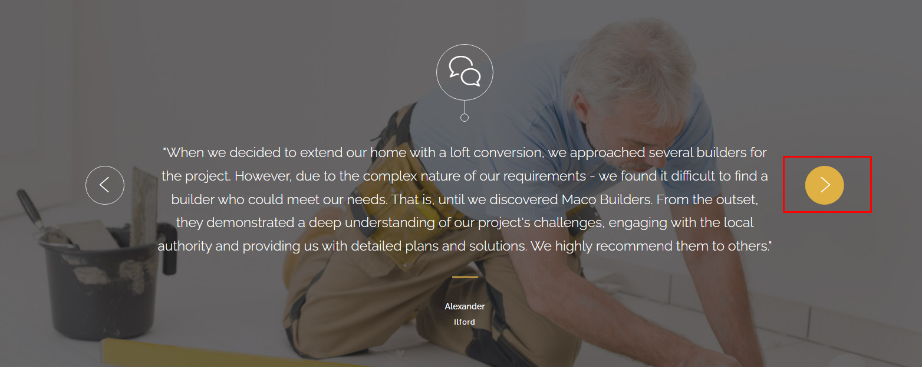

And finally add the footer section like this.  
  
